Meeting Point

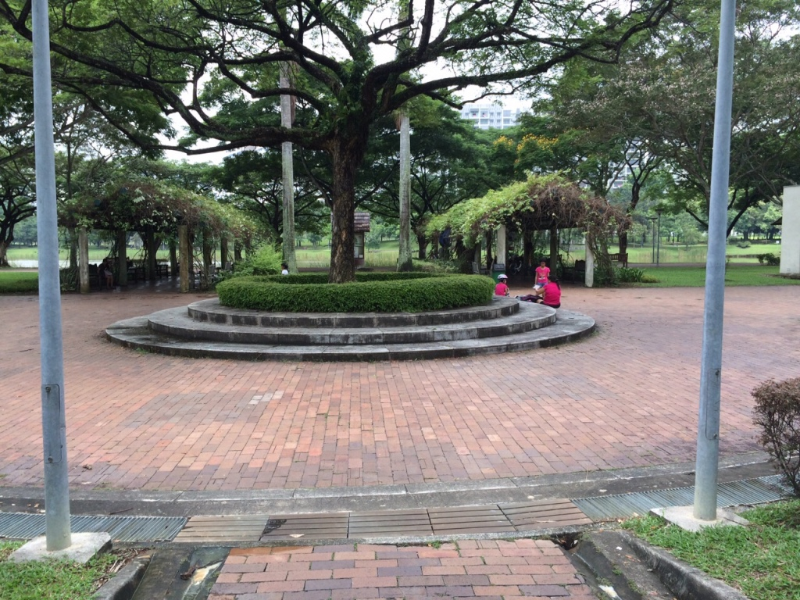

Directions

By bus:
- Take bus 62, 74, 80, 82, 88, 89, 113, 119 or 147 and alight at Punggol Park (bus stop name).
- Signs will be put up to direct you to the meeting point (TBC).

By MRT:
- Alight at Hougang MRT.
- Exit B and walk straight. You will be able to see Punggol CC.
- Cross the road and continue walking straight.
- Cross the next junction (some distance away) and turn right. 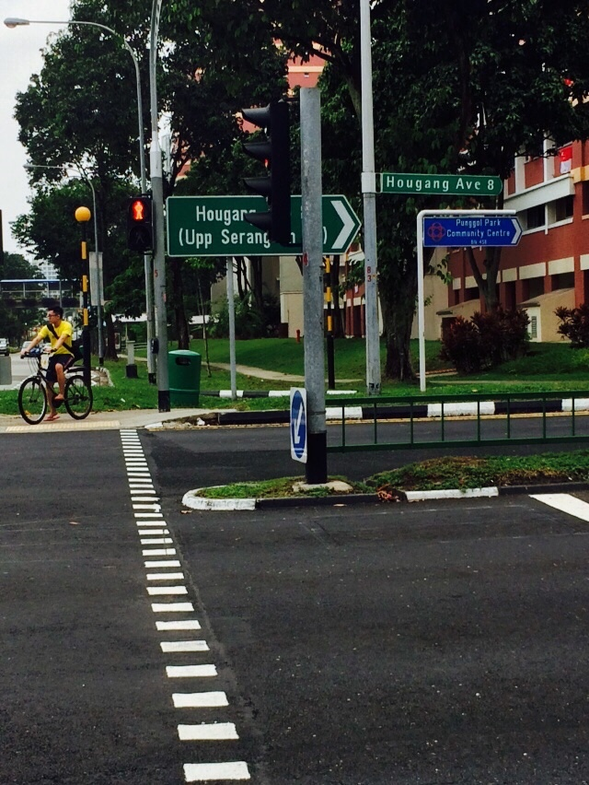
- Walk straight. You will see Punggol Primary School along the way. Continue walking straight and you will reach Punggol Park.